

Aria Workflow Test Execution Document

WFLLA-17(XML Statement Processing)

*Prepared By: Chitra Singh*

*Execution date : 3/FEB/2023*

*Phase 1 : Custom XML Section – Paystub* 2

Use case 1: As a user, I want to verify the below Custom fields are populated in enhanced XML File, when the Account has no payment method, NTG is English and acct_supp_fields contains “Paper Billing”. 2

Use case 2: As a user, I want to verify the below Custom fields are populated in enhanced XML File, when the Account has Tokenised credit card as the Primary payment method, NTG is English and acct_supp_fields contains “PDF”. 4

6

*Phase 2 – Custom XML Section – Account Summary* 7

Use case# 1: As a user, I want to verify the below Custom fields are populated in enhanced XML File when the account Primary payment method is Tokenized Credit card and service_supp1value- "Monthly Charges" 7

Usecase # 2: As a user, I want to verify the below Custom fields are populated in enhanced XML File when the account Primary payment method is Tokenized Credit card and service_supp1value- "Usage Charges" 8

Usecase # 3: As a user, I want to verify the below Custom fields are populated in enhanced XML File when the account Primary payment method is Tokenized Credit card and service_supp1value- "Monthly Charges" 16

Use case # 4: As a user, I want to verify the below Custom fields are populated in enhanced XML File when the account Primary payment method is Tokenized Credit card and service_supp1value- "EquipmentCharges” 31

# *Phase 1 :* *Custom XML Section – Paystub*

# Use case 1: As a user, I want to verify the below Custom fields are populated in enhanced XML File, when the Account has no payment method, NTG is English and acct_supp_fields contains “Paper Billing”.

XML Section – Paystub

1)ps_auto_flag_hd - False

2)ps_cust_typ - B2C

3)ps_cust_class - Blank

4)ps_lang_flag - English

5)ps_print - True

6) ps_att_name - Blank (for future release) 7)header_agreement_id - Blank (for future release) 8)header_invoice_number - Blank (for future release) 9)header_po_number - Blank (for future release)

|  |  |
| --- | --- |
| Action | Details |
| Pre-Conditions | Input XML Statement File with below preconditions  Create an account with below parameter 1)Account no payment method 2)Template name is "LLA XML Template English” 3)supp_field3 contains “Paper Billing” 4) Balance forward amount applied on account |
| WF Server | us-df02 |
| Instance | LLA_DF01 |
| Test Data |  |
| Test Steps |  |
| 1 | 1. Create an account using “create_acct_complete_m” API call in LLADev with below details: 1)Account no payment method 2)Template name is "LLA XML Template English”   3)supp_field3 contains “Paper Billing”  4) Balance forward amount applied on account  Aria core will upload the XML Statement to LLA SFTP |
| 2 | Login to the below work-flow instance,  <https://us-df02.workflow.ariasystems.net/bpa/LLA_DF01/>   1. Navigate to XML Statement Dashboard and run Process File – Main flow   Enhanced XML Statement file will be generated |
|  | Expected Result: <ps_auto_flag_hd>False</ps_auto_flag_hd>  <ps_cust_typ_vrb>B2C</ps_cust_typ_vrb>  <ps_lang_flag_vrb> English</ps_lang_flag_vrb  <ps_print_vrb>True</ps_print_vrb> |
|  | Actual Result: <ps_auto_flag_hd>False</ps_auto_flag_hd>  <ps_cust_typ_vrb>B2C</ps_cust_typ_vrb>  <ps_lang_flag_vrb> English</ps_lang_flag_vrb  <ps_print_vrb>True</ps_print_vrb> |
| Comments | ***PASS*** |
| Account_No | ***33265876*** |
| Input file |  |
| Enhanced XML Output file |  |

Ps_auto_flag_hd

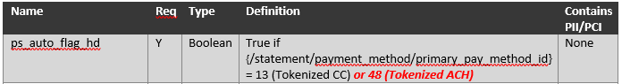

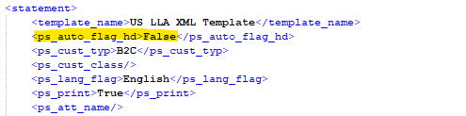

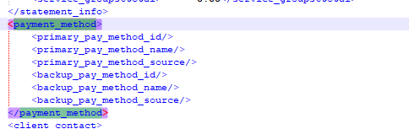

2)ps_cust_typ 3) ps_cust_class 4) ps_lang_flag

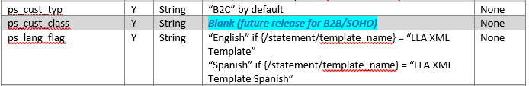

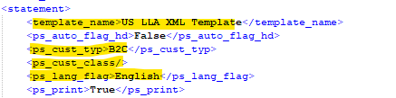

5) ps_print



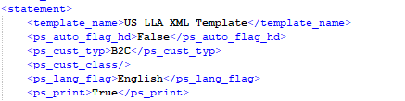

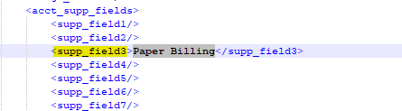

# 

# Use case 2: As a user, I want to verify the below Custom fields are populated in enhanced XML File, when the Account has Tokenised credit card as the Primary payment method, NTG is English and acct_supp_fields contains “PDF”.

XML Section – Paystub

1)ps_auto_flag_hd - TRUE

2)ps_cust_typ - B2C

3)ps_cust_class - Blank

4)ps_lang_flag - Spanish

5)ps_print - FALSE

6) ps_att_name - Blank (for future release) 7)header_agreement_id - Blank (for future release) 8)header_invoice_number - Blank (for future release) 9)header_po_number - Blank (for future release)

|  |  |
| --- | --- |
| Action | Details |
| Pre-Conditions | Create an account with below parameter  1)Account has CC primary payment method  2)Template name is “LLA XML Template Spanish” 3)supp_field3 contains “PDF”  4)primary_pay_method_id = "13" |
| WF Server | us-df02 |
| Instance | LLA_DF01 |
| Test Data |  |
| Test Steps |  |
| 1 | Create an account using “create_acct_complete_m” API call in LLADev with below details  1)Account has CC primary payment method  2)Template name is “LLA XML Template Spanish” 3)supp_field3 contains “PDF”  4)primary_pay_method_id = "13"  Aria core will upload the XML Statement to LLA SFTP |
| 2 | Login to the below work-flow instance,  <https://us-df02.workflow.ariasystems.net/bpa/LLA_DF01/>   1. Navigate to XML Statement Dashboard and run Process File – Main flow   Enhanced XML Statement file will be generated |
|  | Expected Result : <ps_auto_flag_hd>TRUE</ps_auto_flag_hd>  <ps_cust_typ_vrb>B2C</ps_cust_typ_vrb>  <ps_lang_flag_vrb> SPANISH</ps_lang_flag_vrb  <ps_print_vrb>False</ps_print_vrb> |
|  | Actual Result: <ps_auto_flag_hd>TRUE</ps_auto_flag_hd>  <ps_cust_typ_vrb>B2C</ps_cust_typ_vrb>  <ps_lang_flag_vrb> SPANISH</ps_lang_flag_vrb  <ps_print_vrb>False</ps_print_vrb> |
| Comments | ***PASS*** |
| Account_No | ***33265625*** |
| Input File |  |
| Enhanced XML Output file |  |

1) ps_auto_flag_hd



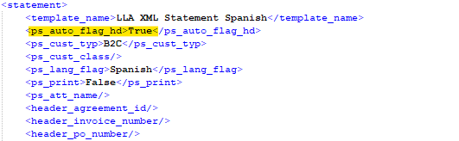

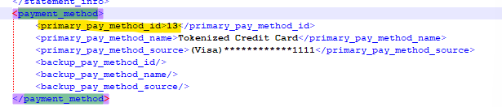

2)ps_lang_flag

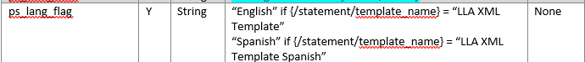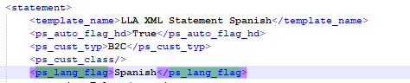

3)ps_print

# 

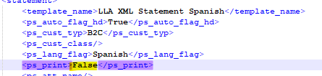

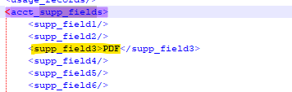

# *Phase 2 – Custom XML Section – Account Summary*

Use case# 1: As a user, I want to verify the below Custom fields are populated in enhanced XML File when the account Primary payment method is Tokenized Credit card and service_supp1value- "Monthly Charges"

XML Section – Account Summary

1)account_summary_previous_balance

2)account_summary_payments

3)account_summary_remaining_balance

|  |  |
| --- | --- |
| Action | Details |
| Pre-Conditions | Create an account with below parameter  1)Account no payment method  2)Template name is "LLA XML Template English”  3)supp_field3 contains “Paper Billing”  4) Balance forward amount applied on account |
| WF Server | us-df02 |
| Instance | LLA_DF01 |
| Test Data |  |
| Test Steps |  |
| 1 | Create an account using “create_acct_complete_m” API call in LLADev with below details  1)account_summary_previous_balance  2)account_summary_payments  3)account_summary_remaining_balance  Aria core will upload the XML Statement to LLA SFTP |
| 2 | Login to the below work-flow instance,  <https://us-df02.workflow.ariasystems.net/bpa/LLA_DF01/>  Navigate to XML Statement Dashboard and run Process File – Main flow  Enhanced XML Statement File will be uploaded to Aria SFTP |
|  | Expected Result:  Enhanced XML statement structure should display below details :  1)account_summary_previous_balance:{/balance_forward}  2)account_summary_payments:sum of all <pay_break_chrg>  3)account_summary_remaining_balance: account_summary_previous_balance – account_summary_payments |
|  | Actual Result:  Enhanced XML statement structure should display below details :  1)account_summary_previous_balance:{/balance_forward}  2)account_summary_payments:sum of all <pay_break_chrg>  3)account_summary_remaining_balance: account_summary_previous_balance – account_summary_payments |
| Comments | ***PASS*** |
| Account_no | ***33265876*** |
| Statement_no | ***2102104847*** |
| Input File |  |
| Enhanced XML Output file |  |

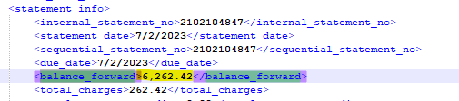

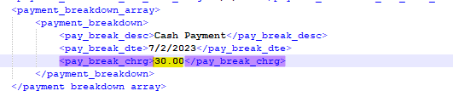

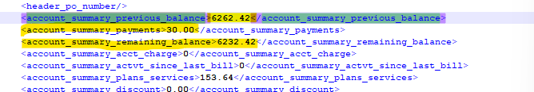

# Usecase # 2: As a user, I want to verify the below Custom fields are populated in enhanced XML File when the account Primary payment method is Tokenized Credit card and service_supp1value- "Usage Charges"

XML Section – Account Summary 1)account_summary_previous_balance

2)account_summary_payments

3)account_summary_remaining_balance

4)account_summary_acct_charge

5)account_summary_actvt_since_last_bill

6)account_summary_discount

7)account_summary_taxes_fees

|  |  |
| --- | --- |
| Action | Details |
| Pre-Conditions | Create an account with below parameter  1)Account has Tokenized CC primary payment method 2)Template name is "LLA XML Template Spanish”  3)supp_field3 contains “PDF”  4) Balance forward amount applied on account 5)service_supp1value- "Usage Charges"  6)Service and Cash credit applied on the account  7)External payment by "Check" |
| WF Server | us-df02 |
| Instance | LLA_DF01 |
| Test Data |  |
| Test Steps |  |
| 1 | Create an account using “create_acct_complete_m” API call in LLADev with below details  1)Account has Tokenized CC primary payment method 2)Template name is "LLA XML Template Spanish” 3)supp_field3 contains “PDF”  4) Balance forward amount applied on account 5)service_supp1value- "Usage Charges"  6)Service and Cash credit applied on the account  7)External payment by "Check" |
| 2 | Login to the below work-flow instance,  <https://us-df02.workflow.ariasystems.net/bpa/LLA_DF01/>  Navigate to XML Statement Dashboard and run Process File – Main flow  Enhanced XML Statement file will be uploaded to Aria SFTP |
|  | Expected Result :  Enhanced XML statement structure should display below details :  1)account_summary_previous_balance:{/balance_forward}  2)account_summary_payments:sum of all <pay_break_chrg>  3)account_summary_remaining_balance: account_summary_previous_balance – account_summary_payments 4)account_summary_actvt_since_last_bill : Sum of {net_price} of {line_item} array {/statement/invoices/invoice /invoice_line_item_charges} where {line_item} has {service_supp1value} = "UsageCharges" 5)account_summary_discount : <gl_credit/> - <gl_total_svc_credits/> 6)account_summary_taxes_fees : <total_tax_charges/> |
|  | Actual Result :  Enhanced XML statement structure displays below details:  1)account_summary_previous_balance:{/balance_forward}  2)account_summary_payments:sum of all <pay_break_chrg>  3)account_summary_remaining_balance: account_summary_previous_balance – account_summary_payments 4)account_summary_actvt_since_last_bill : Sum of {net_price} of {line_item} array {/statement/invoices/invoice /invoice_line_item_charges} where {line_item} has {service_supp1value} = "UsageCharges" 5)account_summary_discount : <gl_credit/> - <gl_total_svc_credits/> 6)account_summary_taxes_fees : <total_tax_charges/> |
| Comments | ***PASS*** |
| Account_no | ***33265703*** |
| Statement_no | ***2102097264*** |
| Input file |  |
| Enhanced XML Output file |  |



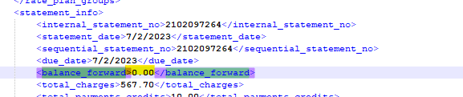

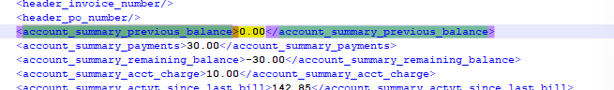



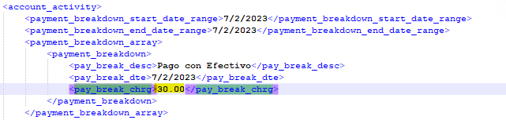

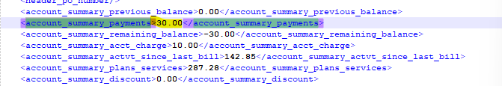

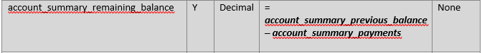

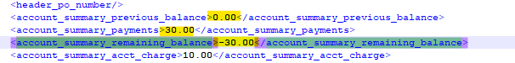

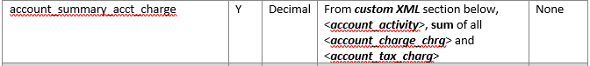

<***account_charge_chrg***> = 15+145+75+850 = 1085

<***account_tax_charg***> = 5.23 + 6.28 + 8.7 + 24.45 = 44.66

<account_summary_acct_charge> = 1085 + 44.66 = 1129.66

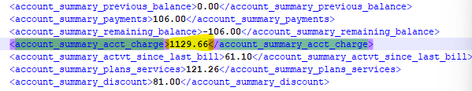

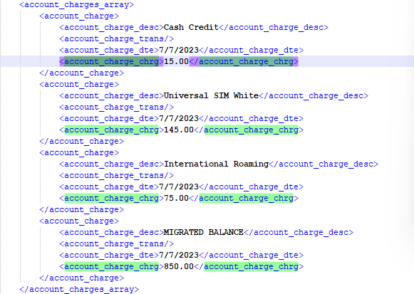

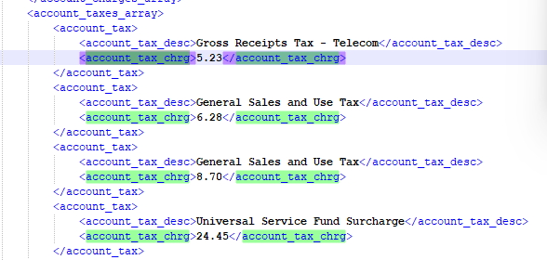

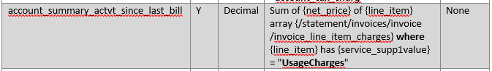

66.75+39+37.10 = 142.85

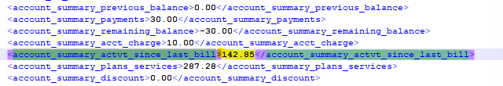

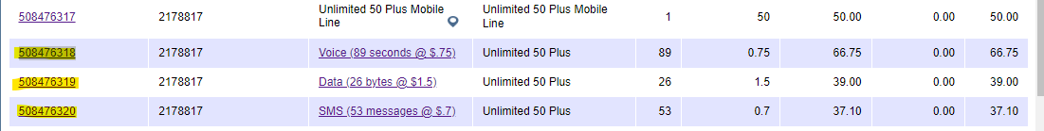

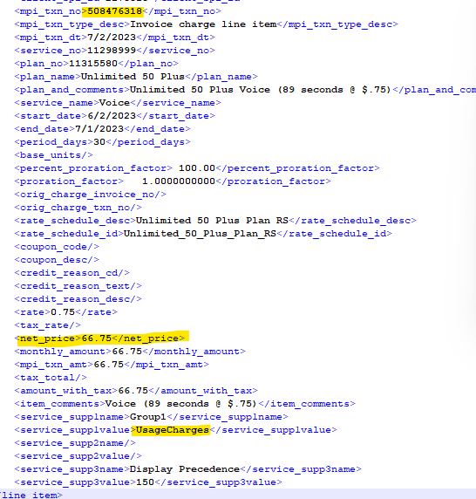

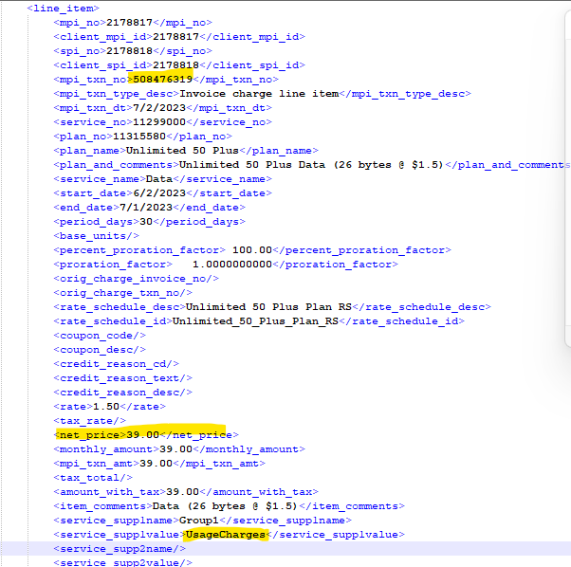

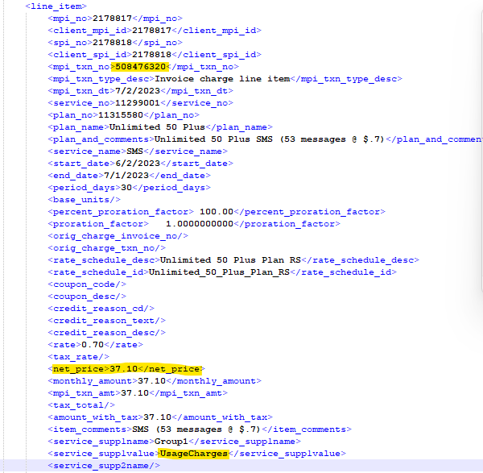





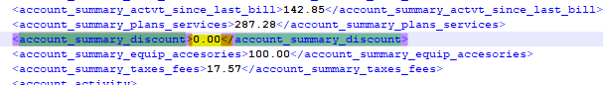





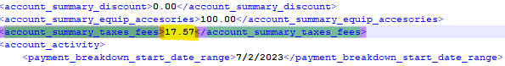

# Usecase # 3: As a user, I want to verify the below Custom fields are populated in enhanced XML File when the account Primary payment method is Tokenized Credit card and service_supp1value- "Monthly Charges"

XML Section – Account Summary 1)account_summary_previous_balance

2)account_summary_payments

3)account_summary_remaining_balance

4)account_summary_acct_charge

5)account_summary_plans_services

6)account_summary_discount

7)account_summary_taxes_fees

|  |  |
| --- | --- |
| Action | Details |
| Pre-Conditions | Create an account with below parameter  1)Account has Tokenized CC primary payment method 2)Template name is "LLA XML Template Spanish”  3)supp_field3 contains “PDF”  4) Balance forward amount applied on account 5)service_supp1value- "Monthly Charges"  6)Service and Cash credit applied on the account  7)External payment by "Check" |
| WF Server | us-df02 |
| Instance | LLA_DF01 |
| Test Data |  |
| Test Steps |  |
| 1 | Create an account using “create_acct_complete_m” API call in LLADev with below details  1)Account has Tokenized CC primary payment method 2) Template name is "LLA XML Template Spanish”  3) supp_field3 contains “PDF”  4) Balance forward amount applied on account  5) service_supp1value- "Monthly Charges"  6) Service and Cash credit applied on the account  7) External payment by "Check"  Aria core will upload the XML Statement to LLA SFTP |
| 2 | Login to the below work-flow instance,  <https://us-df02.workflow.ariasystems.net/bpa/LLA_DF01/>   1. Navigate to XML Statement Dashboard and run Process File – Main flow   Enhanced XML Statement file will be uploaded to Aria SFTP |
|  | Expected Result :  Enhanced XML statement structure should display below details:  1)sum_previous_bal_vrb:{/statement /statement_info /balance_forward}  2)account_summary_payments:sum of all <pay_break_chrg>  4)account_summary_remaining_balance:account_summary_previous_balance – account_summary_payments  5)account_summary_plans_services:Sum of {net_price} of {line_item} array {/statement/invoices/invoice /invoice_line_item_charges} where {line_item} has {service_supp1value} = "MonthlyCharges"  6)account_summary_discount:<gl_credit/> - <gl_total_svc_credits/>  7)account_summary_taxes_fees:<total_tax_charges/> |
|  | Actual Result :  Enhanced XML statement structure displays below details :  1)sum_previous_bal_vrb:{/statement /statement_info /balance_forward}  2)account_summary_payments:sum of all <pay_break_chrg>  4)account_summary_remaining_balance:account_summary_previous_balance – account_summary_payments  5)account_summary_plans_services:Sum of {net_price} of {line_item} array {/statement/invoices/invoice /invoice_line_item_charges} where {line_item} has {service_supp1value} = "MonthlyCharges"  6)account_summary_discount:<gl_credit/> - <gl_total_svc_credits/>  7)account_summary_taxes_fees:<total_tax_charges/> |
| Comments | ***PASS*** |
| Account_no | ***33265625*** |
| Statement_no | ***2102079700*** |
| Input File |  |
| Enhanced XML Output file |  |



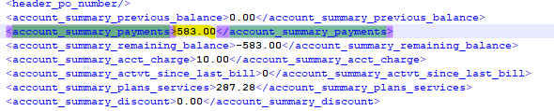

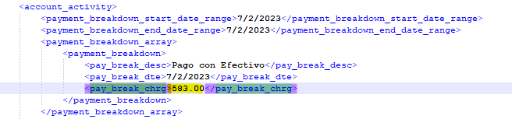

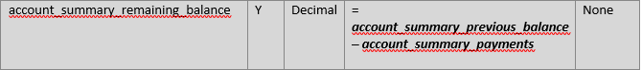



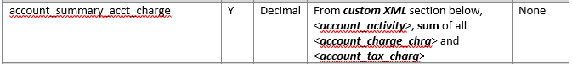

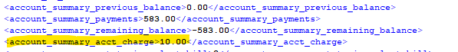

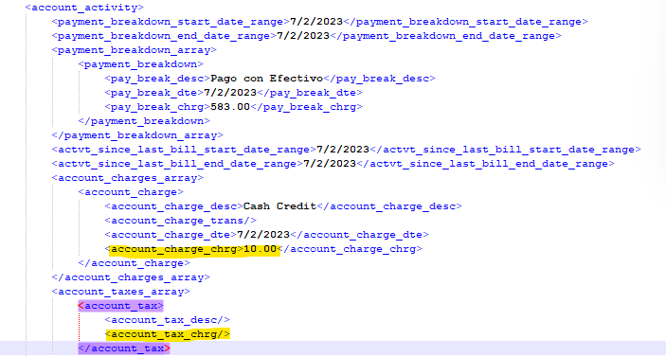

## 

33.64+1.5+1.99+0.15+50+100+100= 287.28

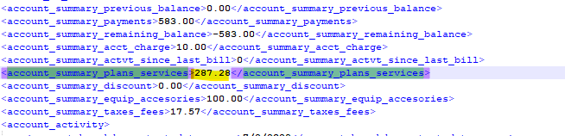

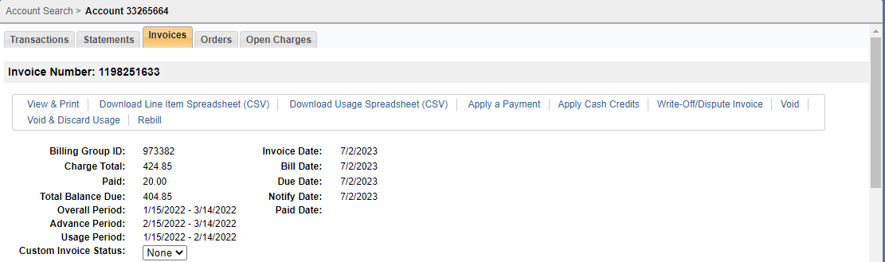

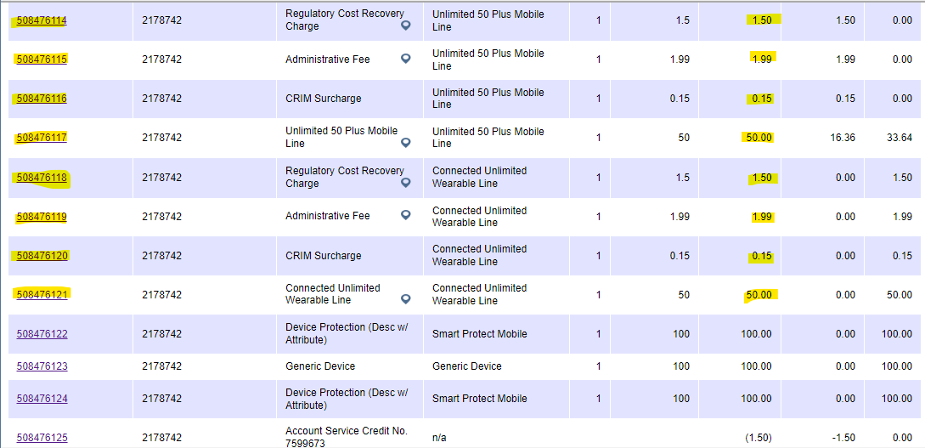

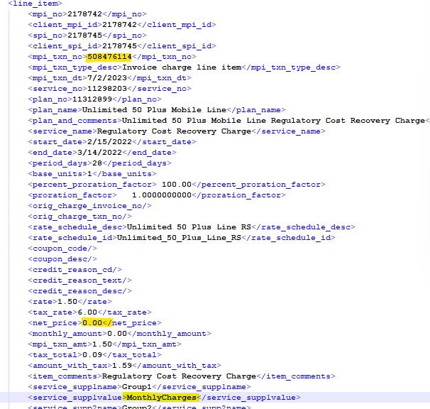

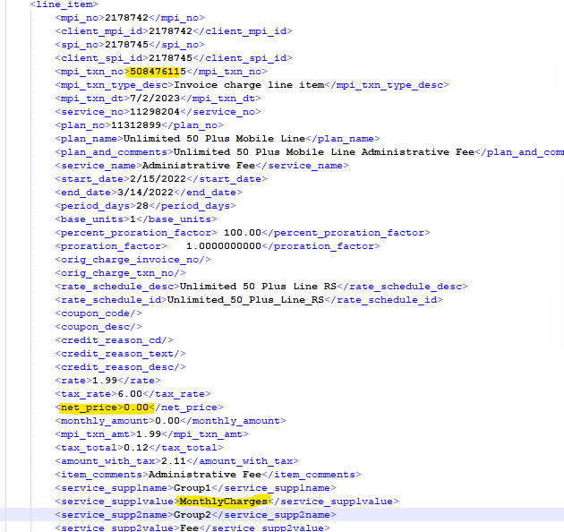

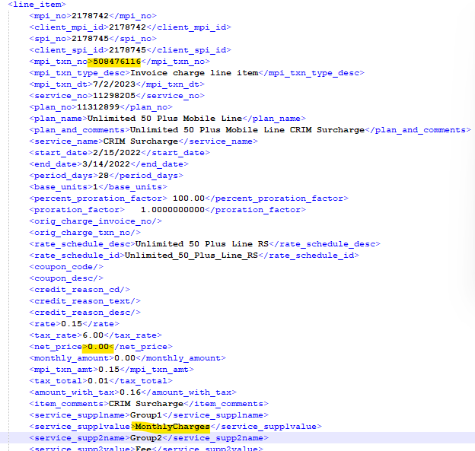

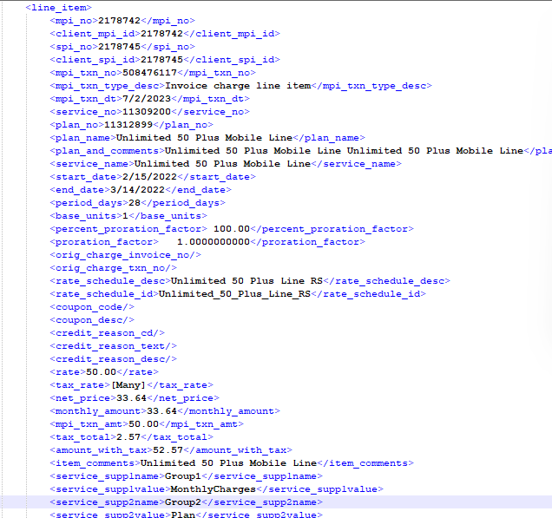

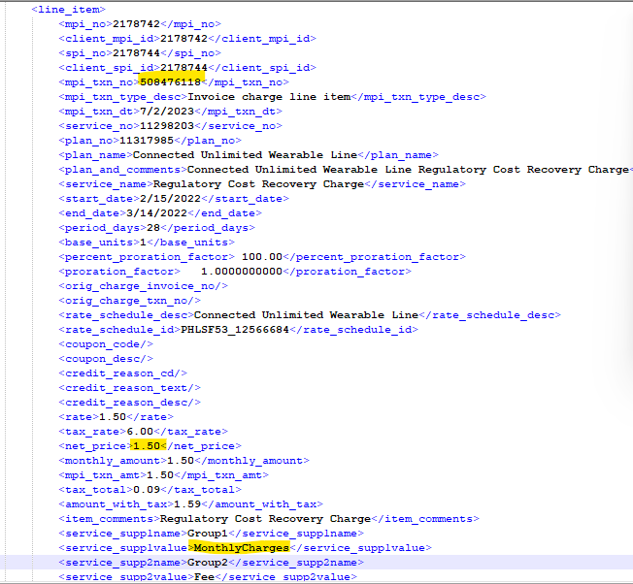

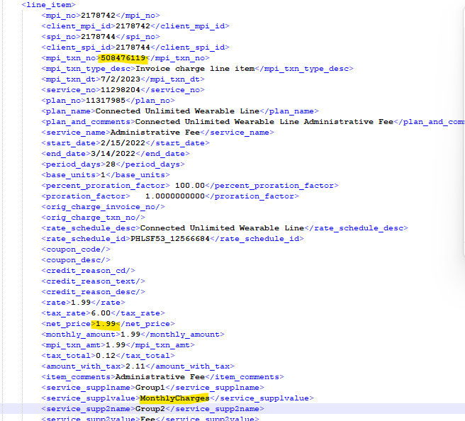

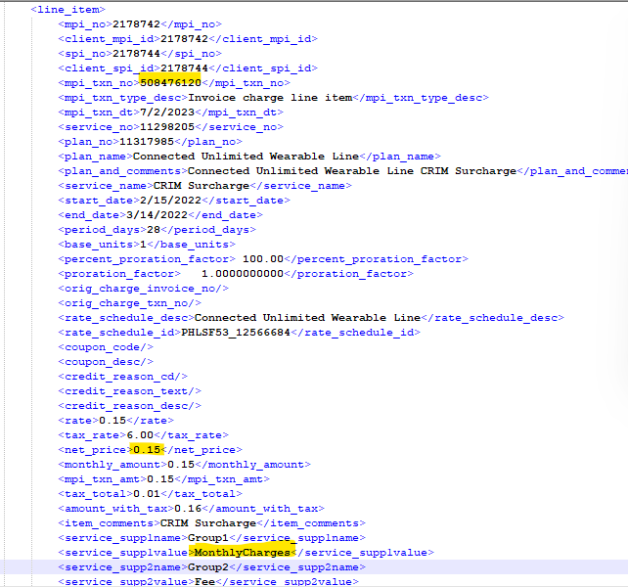

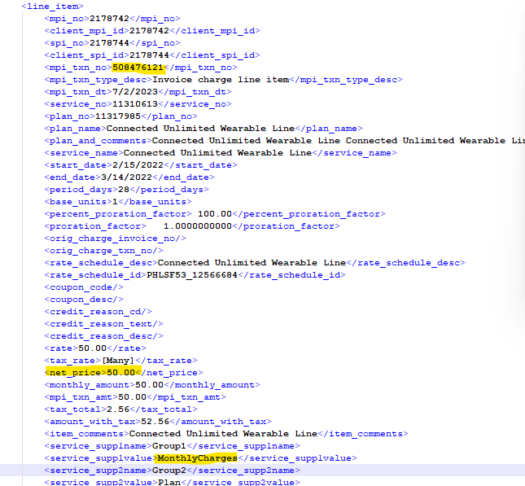

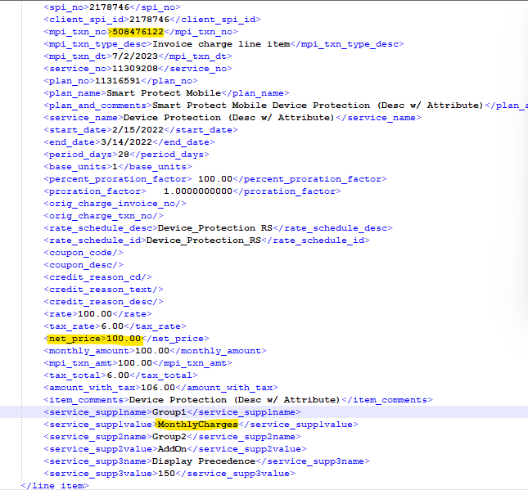

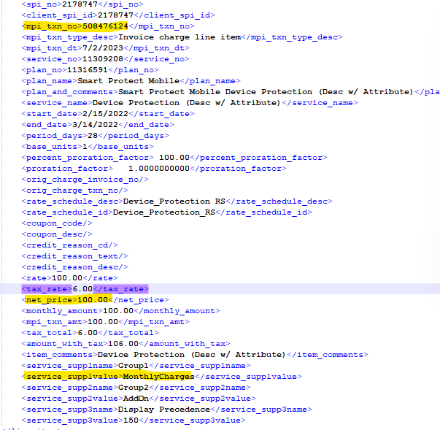

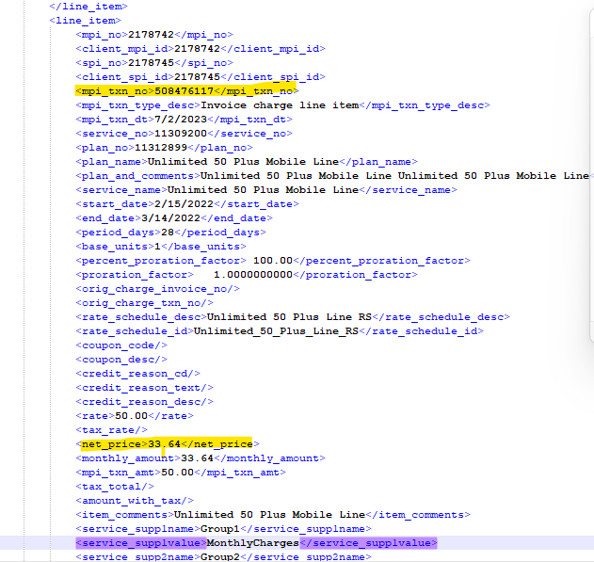



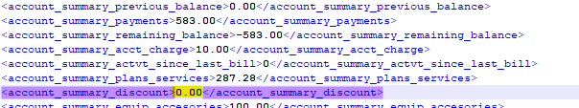



Use case # 4: As a user, I want to verify the below Custom fields are populated in enhanced XML File when the account Primary payment method is Tokenized Credit card and service_supp1value- "EquipmentCharges”

XML Section – Account Summary

1) account_summary_equip_accesories

|  |  |
| --- | --- |
| Action | Details |
| Pre-Conditions | Create an account with below parameter  1) Account has Tokenized CC primary payment method  2) Template name is "LLA XML Template English”  3) supp_field3 contains “PDF”  4) Balance forward amount applied on account  5) service_supp1value- "Equipment Charges"  6) Service and Cash credit applied on the account  7) External payment by "Check" |
| WF Server | us-df02 |
| Instance | LLA_DF01 |
| Test Data |  |
| Test Steps |  |
| 1 | Create an account using “create_acct_complete_m” API call in LLADev with below details  1) Account has Tokenized CC primary payment method  2) Template name is "LLA XML Template English”  3) supp_field3 contains “PDF”  4) Balance forward amount applied on account  5) service_supp1value- "Equipment Charges"  6) Service and Cash credit applied on the account  7) External payment by "Check"  Aria core will upload the XML Statement to LLA SFTP |
| 2 | Login to the below work-flow instance,  <https://us-df02.workflow.ariasystems.net/bpa/LLA_DF01/>   1. Navigate to XML Statement Dashboard and run Process File – Main flow   Enhanced XML Statement file will be uploaded to Aria SFTP |
|  | Expected Result :  Enhanced XML statement structure should display below details:  account_summary_equip_accesories : Sum of {net_price} of {line_item} array {/statement/invoices/invoice /invoice_line_item_charges} where {line_item} has {service_supp1value} = "EquipmentCharges" |
|  | Actual Result :  Enhanced XML statement structure displays below details:  account_summary_equip_accesories : Sum of {net_price} of {line_item} array {/statement/invoices/invoice /invoice_line_item_charges} where {line_item} has {service_supp1value} = "EquipmentCharges" |
| Comments | ***PASS*** |
| Account_no | ***33265893*** |
| Statement_no | ***2102104938*** |
| Input File |  |
| Enhanced XML Output file |  |

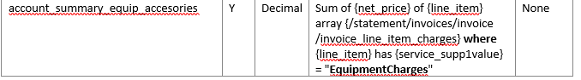

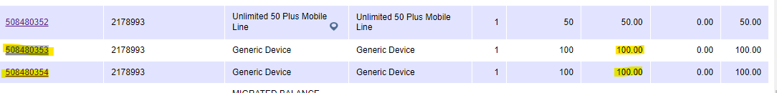

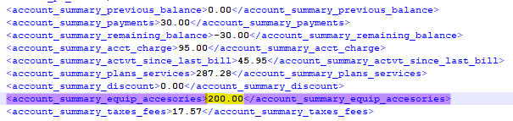

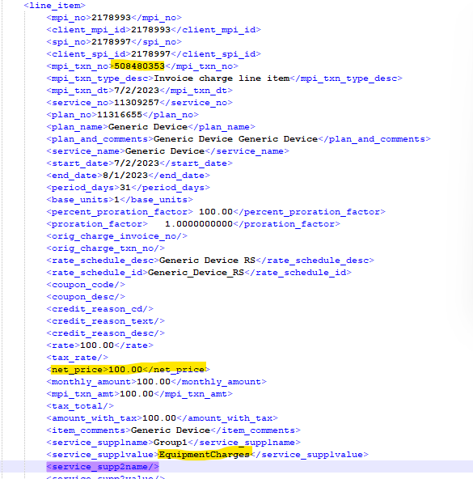

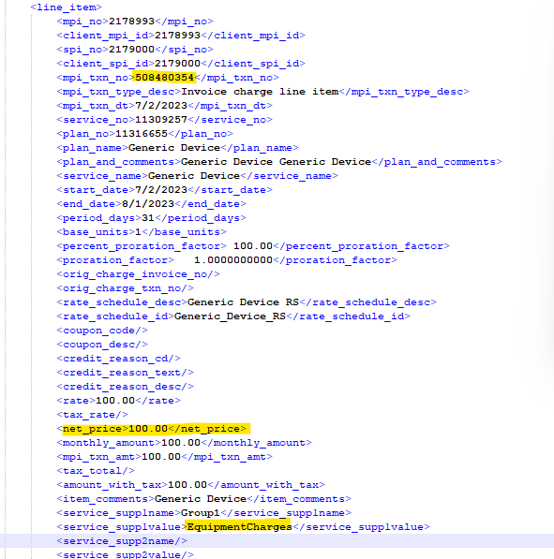

# *Phase 3: Custom XML Section – Account Activity*